PROJECT FINAL REPORT

YUVANESH.R
24BCE2487

Title:
Smart Vehicle Rental Management.

Summary:
The Smart Vehicle Rental Management System is a console-based application developed using Java with MongoDB as the database. The system provides a digital solution for managing vehicle rentals, customers, payments, and administrative operations.
The application follows a layered architecture consisting of models, services, utilities, database connection, and main user interface modules. It allows administrators to manage vehicles, customers, rentals, and payments, while customers can register, log in, rent vehicles, return vehicles, and view their rental and payment history.
MongoDB is used to store all application data in collections such as customers, admins, vehicles, rentals, and payments.

Objective:
The main objective of this project is to automate the vehicle rental process by replacing manual record management with a secure and efficient computerized system.
The system aims to:
- Provide secure admin and customer login.
- Maintain customer records.
- Manage vehicle availability.
- Handle vehicle booking and return operations.
- Calculate rental charges automatically.
- Manage payment details.
- Store and retrieve data efficiently using MongoDB.

Tools and Technologies Used:

Tool / Technology | Version
Programming Language | Java JDK 8
IDE | Eclipse IDE (2025 version or latest installed version)
Build Tool | Apache Maven 3.x
Database | MongoDB Community Server 8.x
Database GUI | MongoDB Compass (latest version)
MongoDB Java Driver | 5.5.1
Operating System | Windows 10/11

System Modules:

Admin Module
- Admin login authentication.
- Add, update, search, and delete vehicles.
- View customer details.
- Manage rental records.
- Manage payment records.
Customer Module
- Customer registration and login.
- Browse available vehicles.
- Rent a vehicle.
- Return rented vehicles.
- View rental history.
- View payment history.
Vehicle Module
- Stores vehicle information such as:
  - Vehicle ID
  - Vehicle Name
  - Vehicle Type
  - Brand
  - Model
  - Price per day
  - Availability status
Rental Module
- Creates rental records.
- Validates customer and vehicle details.
- Calculates total rental amount automatically.
- Updates vehicle availability during booking and return.
Payment Module
- Records payment information.
- Stores payment method, amount, date, and payment status.
- Allows payment tracking and management.
5. Database Collections
The MongoDB database vehicle_rental_system contains the following collections:
- admins
- customers
- vehicles
- rentals
- payments

Outcome:

The Smart Vehicle Rental Management System was successfully developed and tested. The application can perform customer management, vehicle management, rental processing, payment handling, and database operations effectively.
The project demonstrates the integration of Java with MongoDB using the MongoDB Java Driver and follows a structured Maven-based project architecture.

Advantages:
- Reduces manual paperwork.
- Provides quick data retrieval.
- Maintains vehicle availability status automatically.
- Prevents double booking of vehicles.
- Stores customer and payment history securely.
- Easy to maintain and extend.

Screenshots:

SET-1:
The 1st set screenshots explains that to registration of the customer the menu asks to enter the choice as we enter 2 we get into the customer registration menu where we are being asked to fill our personal details and finally asked to create username and password [note: password must be created with upper case and lower case minimum of 8 digit] if we does all required accurately then we get a message of customer registered successfully with an id for them, these stuffs will get stored into the database which we created in mongodb without any errors these things are practically shown in below set1 screenshots.
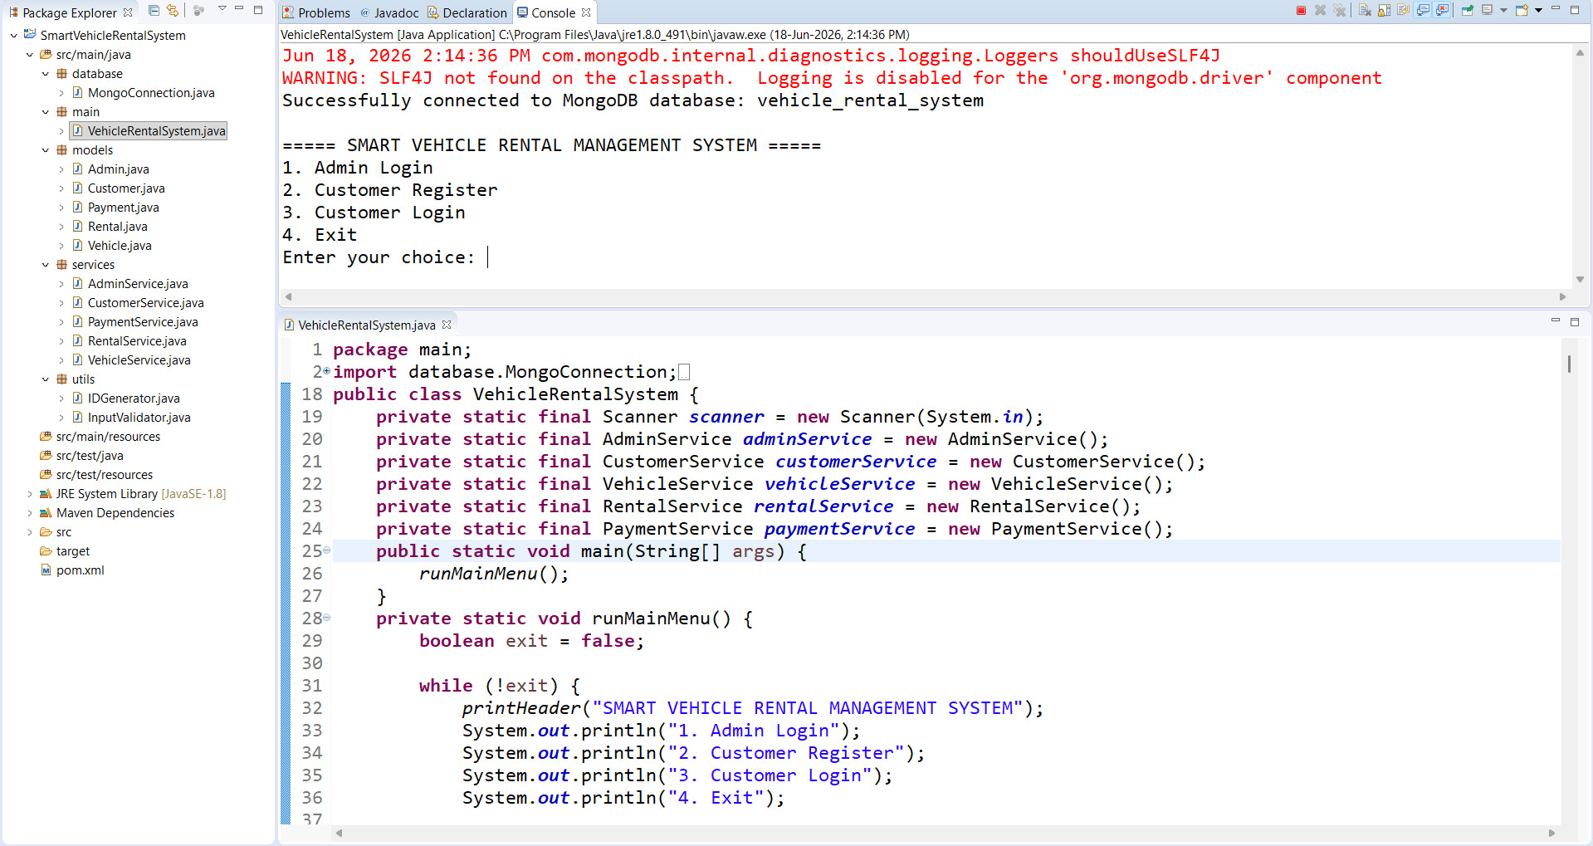

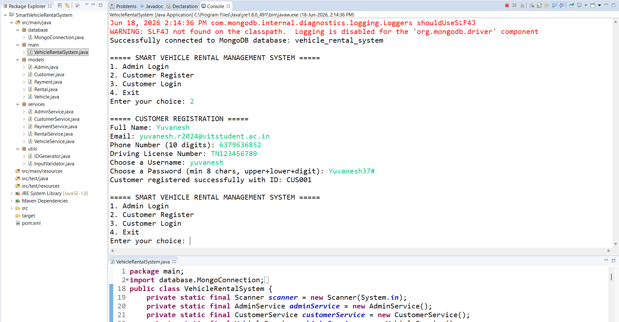
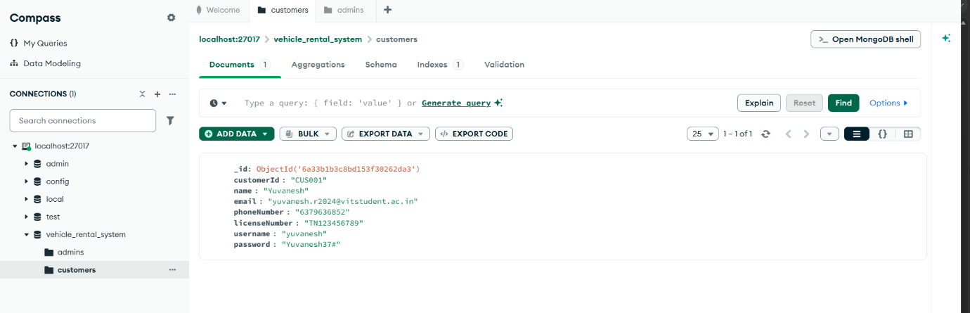

SET-2:

The set 2 explains that addition of admin details in database so only admin can access the admin login menu. Admin can access many functions one of the main functions is explained below in set 2 screenshots, those screenshots explain the addition of vehicle and generating vehicle id. The menu asks the details of the vehicle in detail so that admin must be careful in registering the vehicle.

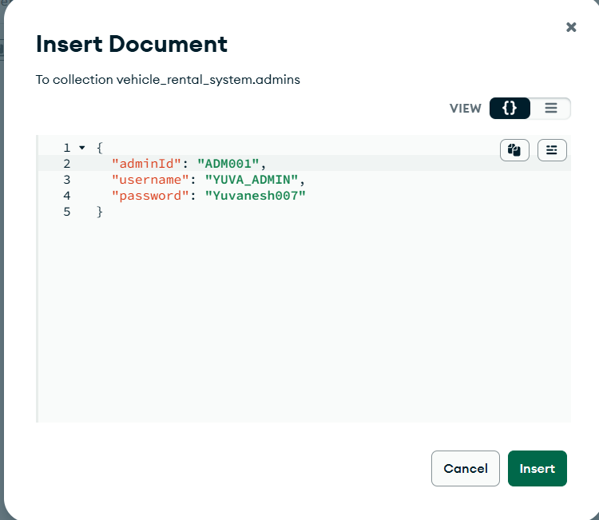

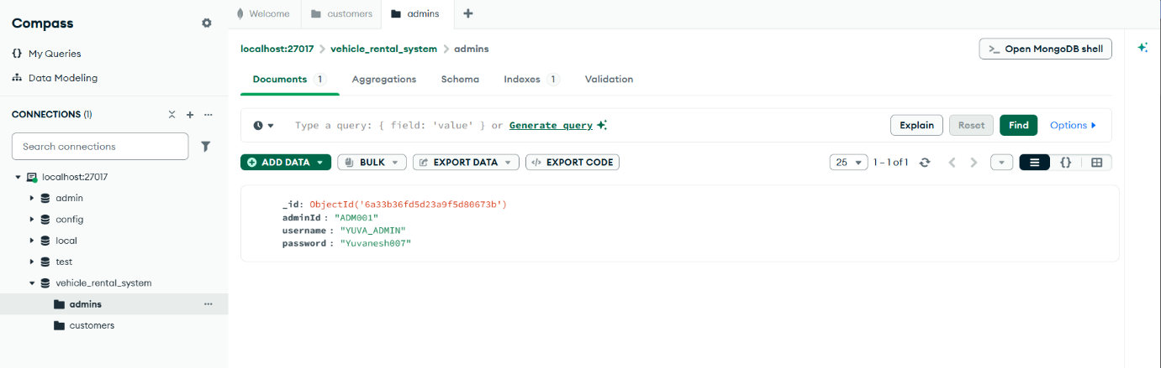
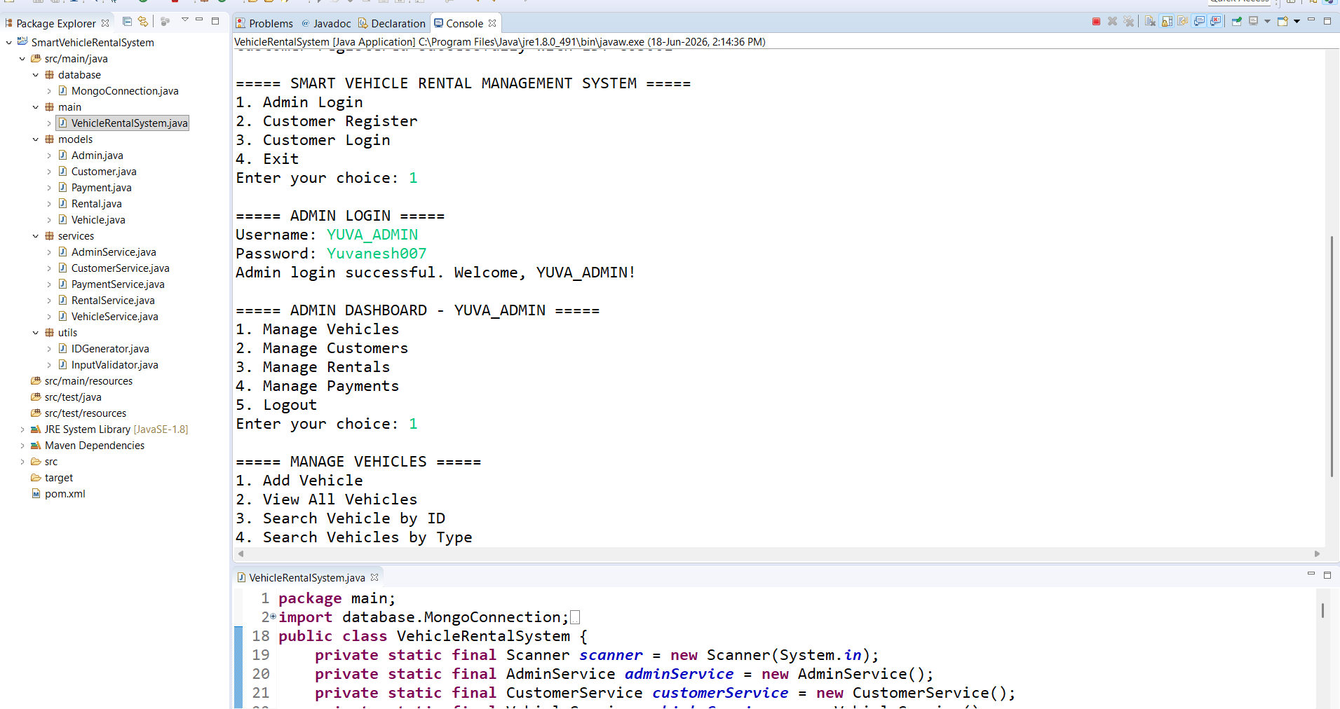
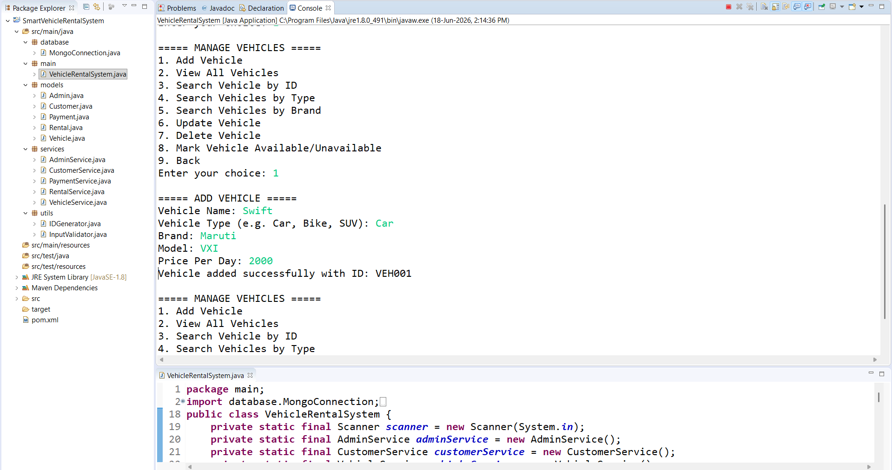
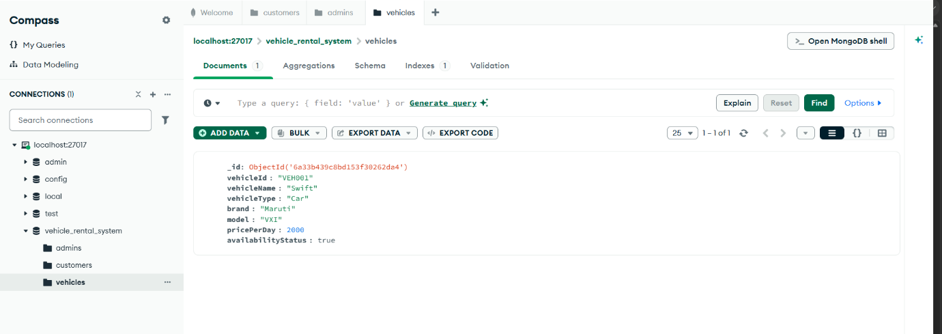
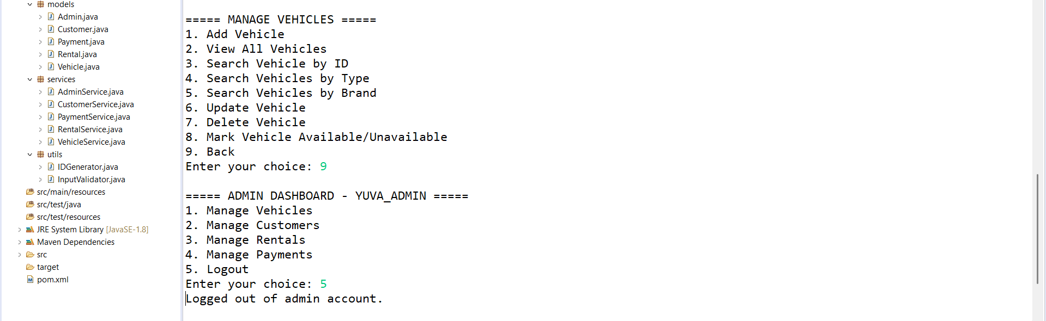

SET-3:
This set explains again the login part of customer shortly and goes into the main part that is taking rent of the vehicle it asks several question vehicle id, date of taking rental,no of days after that it generates rental id and amount need to be paid and amount can be paid by various options like upi,card,cash if the payment is done it gives a successful message and payment id.The compass database stores all the activites accurately. This what the below screenshots explain.

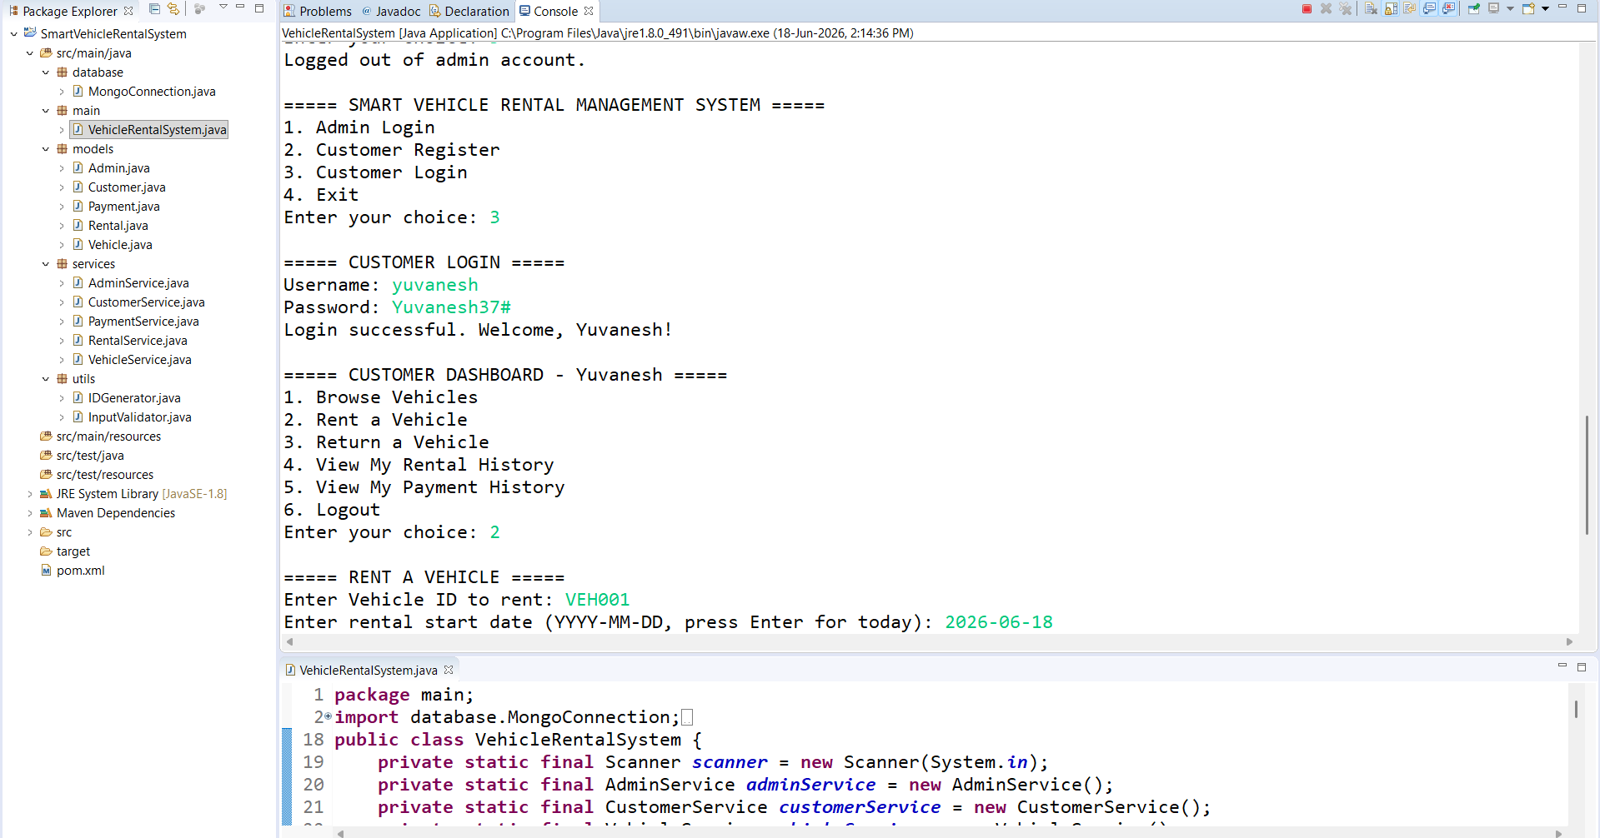

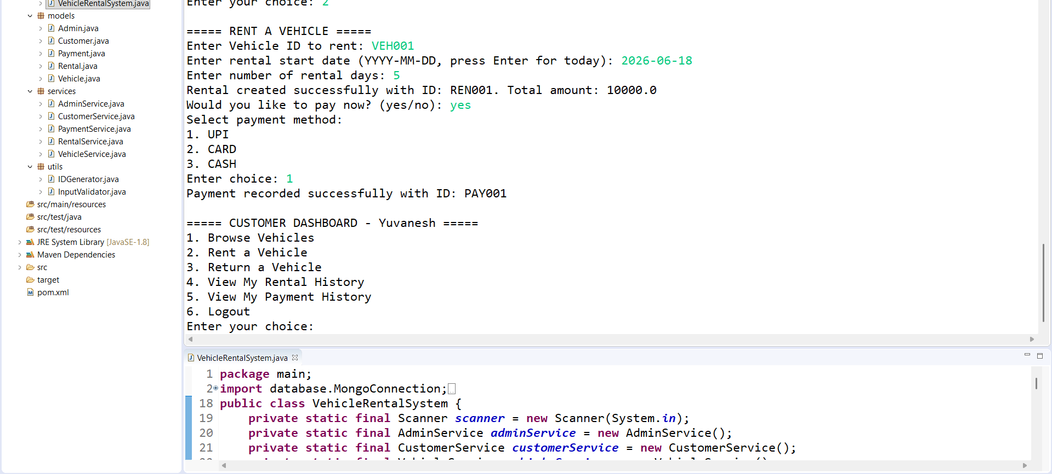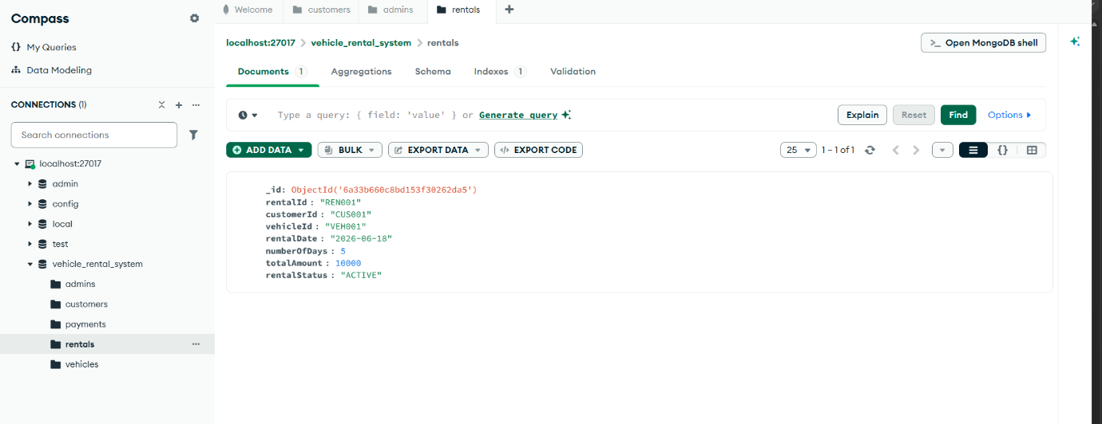
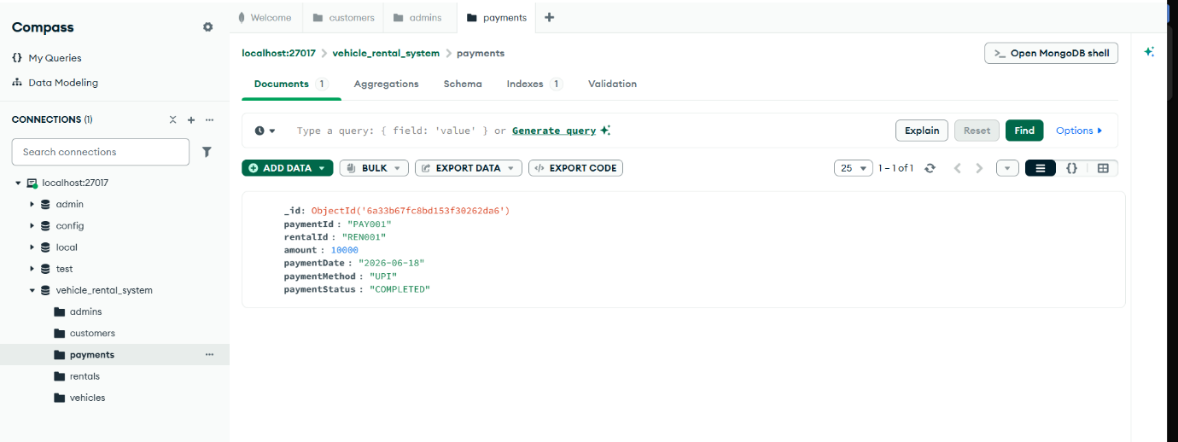

Conclusion:
The Smart Vehicle Rental Management System was successfully designed and developed as a console-based Java application integrated with MongoDB for database management. The system provides a complete solution for handling the major operations involved in a vehicle rental service, including administrator management, customer registration and authentication, vehicle management, rental booking, vehicle return, and payment management.
The project follows a structured architecture using separate layers for models, services, utilities, database connection, and the main application, which improves the readability, maintainability, and scalability of the system. The use of Maven helped in managing external dependencies, especially the MongoDB Java Driver, while Eclipse IDE provided an efficient development and debugging environment.
Through testing, the system was able to successfully perform important functionalities such as adding customer records into MongoDB, validating user logins, managing vehicle availability during rentals and returns, generating unique IDs for different entities, and recording payment details. The data was stored and verified using MongoDB Compass, ensuring proper interaction between the application and the database.
This project also demonstrates the practical implementation of Object-Oriented Programming concepts such as classes, objects, encapsulation, and modular design along with database connectivity. Error handling and input validation were implemented to improve reliability and provide a better user experience.
Overall, the Smart Vehicle Rental Management System meets its intended objectives by providing a simple, efficient, and reliable platform for managing vehicle rental operations. The project can be further enhanced in the future by developing a graphical user interface, adding online payment gateway integration, implementing advanced search and reporting features, and deploying it as a web or mobile application for real-world usage.

